TEAM 7

TEAM MEMBERS
ROLL NO :
23BTT001
23BTT036
23BTT040
23BTT306
23BTT310
22BTT017

Report on Different Types of Sensors Using Arduino

1. Ultrasonic Sensor (HC-SR04)
Sensor Type: Ultrasonic Distance Sensor
Objective: To measure the distance of an object using ultrasonic sound waves with Arduino.

Components Required
- Arduino Uno
- HC-SR04 Ultrasonic Sensor
- Jumper wires
- Laptop with Arduino IDE
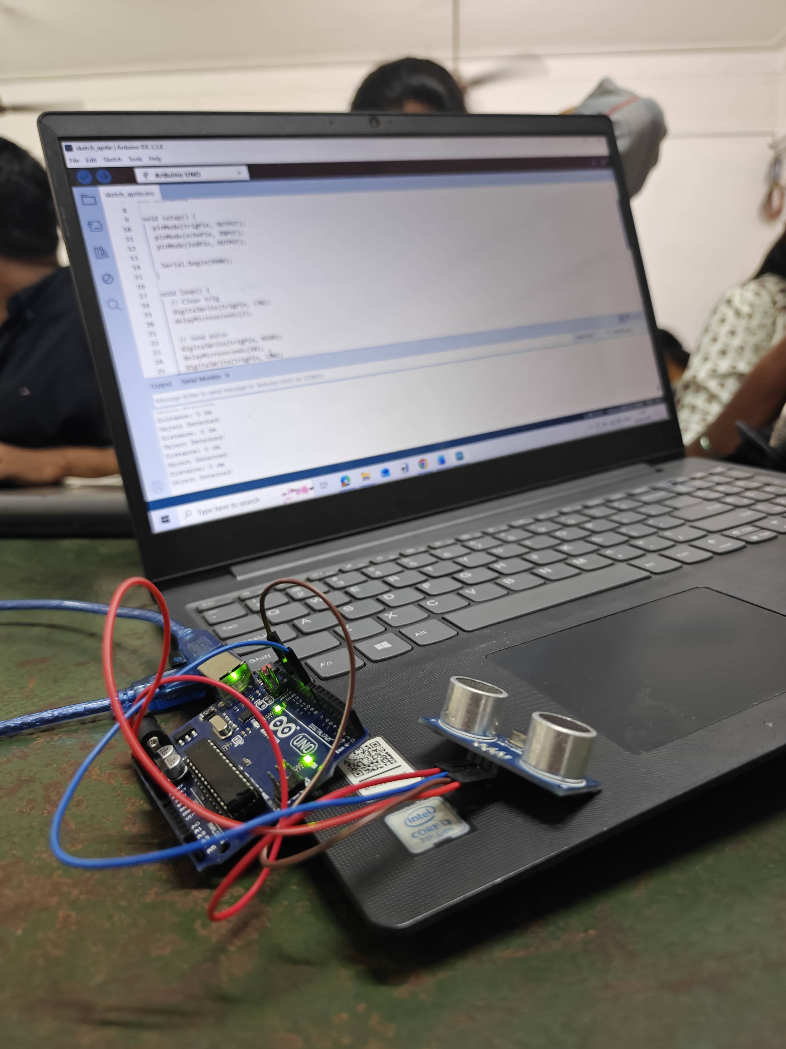

Working Principle
The ultrasonic sensor sends a sound pulse from the trigger pin. The sound wave travels through air and reflects back when it hits an object. The echo pin receives the reflected signal and Arduino calculates the distance based on the time taken.

Arduino Connections
VCC → 5V
GND → GND
Trig → Pin 9
Echo → Pin 10

Arduino Program
const int trigPin = 9;
const int echoPin = 10;
long duration;
int distance;
void setup() {
Serial.begin(9600);
pinMode(trigPin, OUTPUT);
pinMode(echoPin, INPUT);
}
void loop() {
digitalWrite(trigPin, LOW);
delayMicroseconds(2);
digitalWrite(trigPin, HIGH);
delayMicroseconds(10);
digitalWrite(trigPin, LOW);
duration = pulseIn(echoPin, HIGH);
distance = duration * 0.034 / 2;
Serial.print("Distance: ");
Serial.print(distance);
Serial.println(" cm");
delay(500);
}

2. Temperature and Humidity Sensor (DHT11)
Sensor Type: Temperature and Humidity Sensor
Objective: To measure environmental temperature and humidity using Arduino.

Components Required
- Arduino Uno
- DHT11 Sensor
- Jumper wires
- Laptop with Arduino IDE
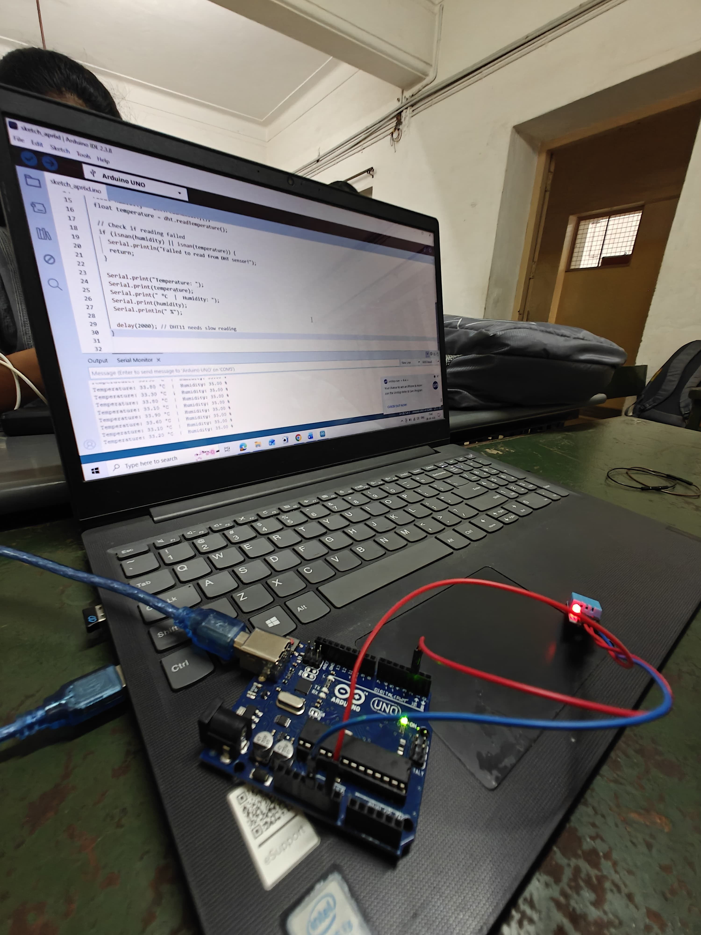

Working Principle
The DHT11 sensor measures temperature using a thermistor and humidity using a capacitive humidity sensor. The sensor converts these readings into digital signals and sends them to the Arduino.

Arduino Connections
VCC → 5V
GND → GND
DATA → Pin 2

Arduino Program
#include "DHT.h"
#define DHTPIN 2
#define DHTTYPE DHT11
DHT dht(DHTPIN, DHTTYPE);
void setup() {
Serial.begin(9600);
dht.begin();
}
void loop() {
float humidity = dht.readHumidity();
float temperature = dht.readTemperature();
if (isnan(humidity) || isnan(temperature)) {
Serial.println("Failed to read from DHT sensor");
return;
}
Serial.print("Temperature: ");
Serial.print(temperature);
Serial.print(" °C ");
Serial.print("Humidity: ");
Serial.print(humidity);
Serial.println(" %");
delay(2000);
}

3. IR Sensor for Object Detection
Sensor Type: Infrared Object Detection Sensor
Objective: To detect the presence of an object using infrared light with Arduino.

Components Required
- Arduino Uno
- IR Obstacle Detection Sensor Module
- Jumper wires
- Laptop with Arduino IDE
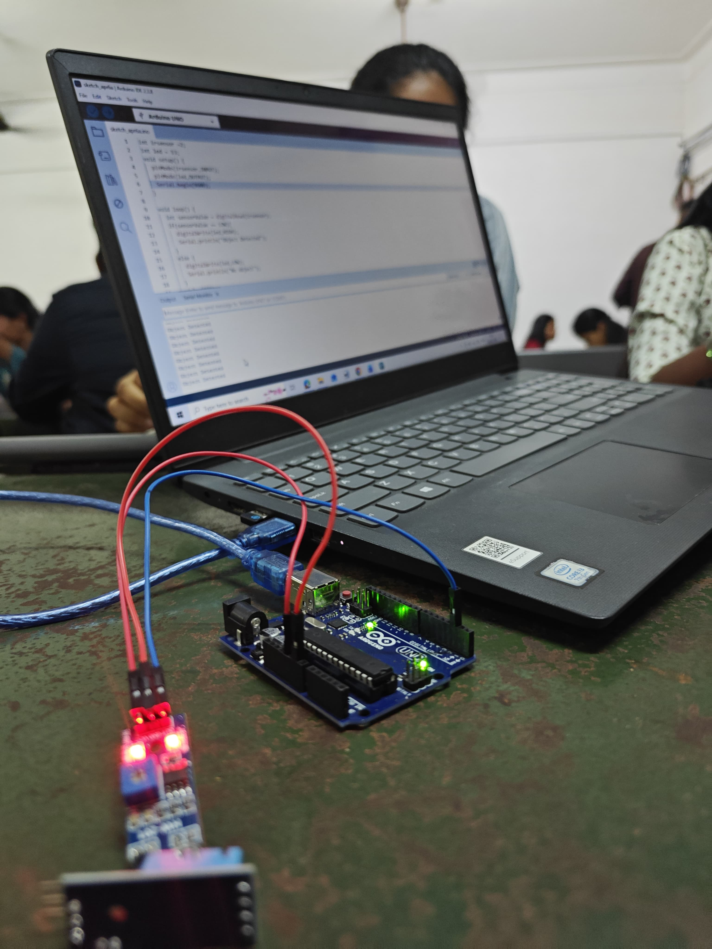

Working Principle
The IR sensor consists of an infrared LED transmitter and a receiver photodiode. The transmitter emits infrared light. When an object is placed in front of the sensor, the light reflects back and is detected by the receiver. The module then sends a signal to the Arduino indicating that an object has been detected.

Arduino Connections
VCC → 5V
GND → GND
OUT → Pin 7

Arduino Program
int sensorPin = 7;
void setup() {
pinMode(sensorPin, INPUT);
Serial.begin(9600);
}
void loop() {
int objectState = digitalRead(sensorPin);
if(objectState == LOW) {
Serial.println("Object Detected");
} else {
Serial.println("No Object");
}
delay(500);
}

Conclusion
In this experiment, different sensors such as Ultrasonic Sensor, DHT11 Temperature and Humidity Sensor, and IR Object Detection Sensor were interfaced with Arduino Uno. The sensors successfully measured distance, environmental conditions, and object detection. This experiment helped in understanding sensor interfacing and real-time monitoring using Arduino.

